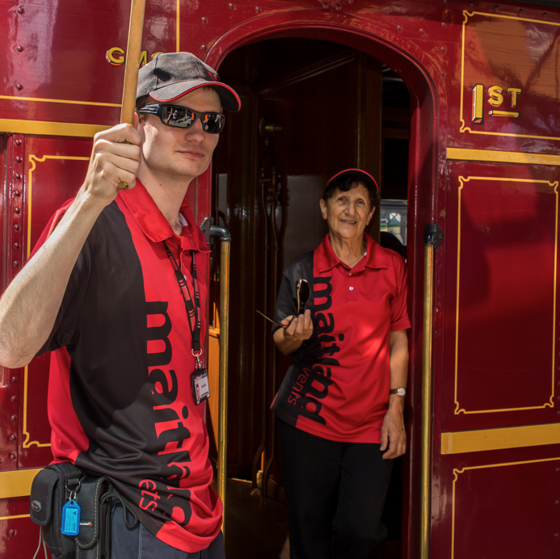


2026
Events Volunteer Application Form

2026
Event Volunteer Application Form

Applicant details

Persons must be aged 14 years and 9 months or older to be eligible to apply.

Name

Date of birth

Postal address

Town/city Postcode

Phone

Mobile

Email address

Preferred contact method

☐ Email ☐ Phone call
☐ Text ☐ Letter

If applicable, list the service club that you are volunteering on behalf of

Emergency contact

Name

Contact number

Volunteering details

Have you volunteered for Maitland events previously? Y ☐ N ☐

Do you have a Maitland events volunteer shirt? Y ☐ N ☐
If no, circle or tick your shirt size.
S ☐ M ☐ L ☐ XL ☐ 2XL ☐
3XL ☐ 4XL ☐ 5XL ☐

Do you have a Maitland events volunteer bucket hat? Y ☐ N ☐

Do you have a current certificate in any of the following? (provide copies with form)
☐ RSA
☐ Working with children check
☐ First Aid

Do you have any medical condition/s that we should be aware of? Y ☐ N ☐
If yes, please detail:

First time volunteers
Please be aware that no previous experience is required. The following questions are used as a guide for the events team to place volunteers in the most appropriate roles based on their previous experience.

Festival/event Y ☐ N ☐
Please detail:

Customer service Y ☐ N ☐
Please detail:

Cash handling Y ☐ N ☐
Please detail:

Sales Y ☐ N ☐
Please detail:

Availability
Please tick all appropriate boxes:

Australia Day / Dive in Cinema
Monday 26 January 2026
am ☐ pm ☐ all ☐

Summer Activities
Various dates
am ☐ pm ☐ all ☐

Hunter Valley Steamfest
Saturday 18 April and Sunday 19 April 2026
am ☐ pm ☐ all ☐

Luminous
Friday 19 June and Saturday 20 June 2026
am ☐ pm ☐ all ☐

Maitland Riverlights
Saturday 10 October 2026
am ☐ pm ☐ all ☐

Maitland New Year’s Eve
Thursday 31 December 2026
am ☐ pm ☐ all ☐

Other Activities
Ongoing dates
am ☐ pm ☐ all ☐

A Maitland events staff member will contact you closer to each event to confirm details. Shifts may be available pre and post event, if you are interested, please let the staff member know. Event information provided may be subject to change.

Privacy and personal information
Council is committed to privacy protection and complies with the Privacy and Personal Information Protection Act 1998 and Government Information Public Access Act 2009. The Maitland City Council Privacy Management Plan can be found online at: https://www.maitland.nsw.gov.au/ document/privacy-management-plan-0 The personal information collected on this form will be used to provide contact information and determine appropriate work and safety environments to perform volunteer functions. The intended recipients are Maitland City Council events team or other Maitland City Council staff and their contractors as required. The supply of this information is voluntary, though Council will be unable to accept the application without it.

Volunteering conditions
I agree to act as a volunteer on behalf of Maitland City Council. I understand that if I am accepted as a volunteer I will be required to attend a compulsory Volunteer Induction training session where I will receive the Festival Volunteer Manual and that I will be required to comply with all conditions outlined in the training / manual. I understand that upon receipt of the training / manual if I am unable or unwilling to comply with all conditions that I can choose to withdraw my application.
Personal information obtained from volunteers by Council is governed by the Privacy and Personal Information Protection Act 1998 (PPIPA).
This legislation provides direction for the collection, protection, storage, disposal, access and use of personal information by Council.
If you are volunteering to work with the elderly, people with disability, youth and/or children, you may be required to consent to Council undertaking a criminal record check. Are you willing to give permission to undertake the check?
Y ☐ N ☐

Signature Date

If you are under the age of 18 years you must have a parent or guardian sign the application form below to advise that they are aware of your application to volunteer with Maitland City Council:

Signature of parent/guardian

Print name Date

Please return completed form to
Maitland City Council events
PO Box 220, Maitland NSW 2320
events@maitland.nsw.gov.au 02 4931 2801 (for more information)

